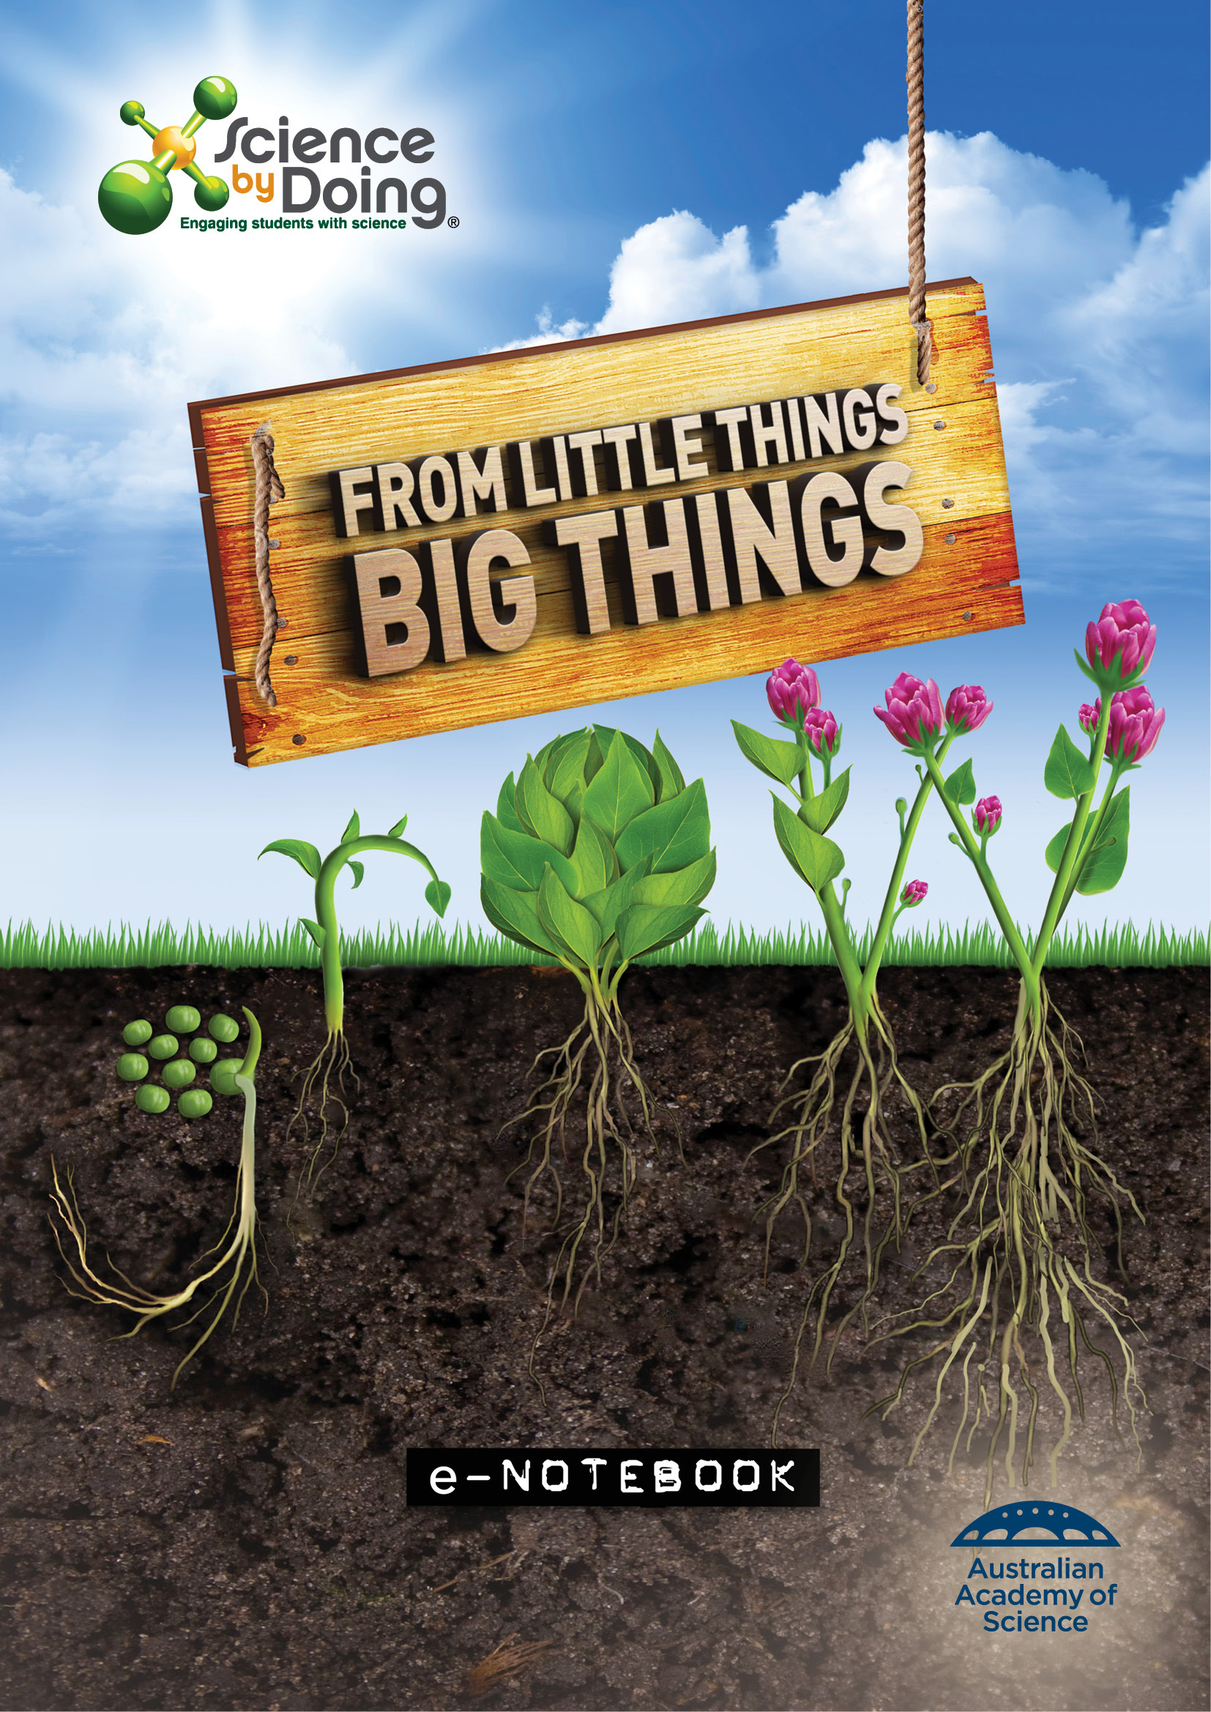

User Guide

Word for PCs
For ease of navigation we suggest you turn on the Navigation Pane located under the View tab in the menu bar.


Word for Mac
For ease of navigation we suggest you turn on the Document Map Pane located under the View tab in the menu bar. Select the View tab, select Sidebar then Document Map pane.

This will open up a clickable Navigation column on the left hand side of the document.

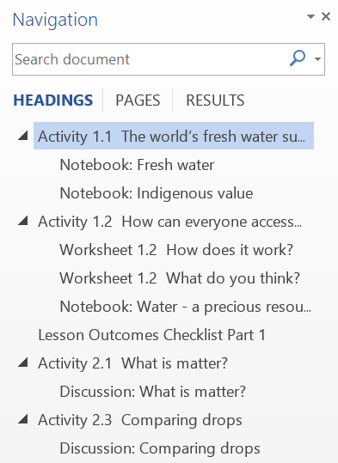

You can select the various elements of each Activity and move through the document with greater ease.

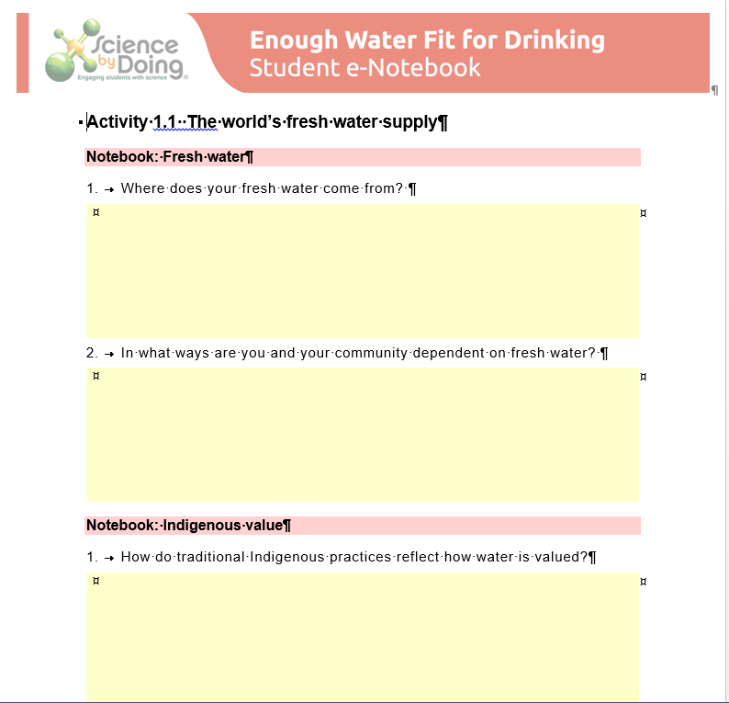

Activity 1.1 Living or non-living?

Notebook: Signs of life
Copy the table below into your Notebook or download the e-Notebook. Rollover each photo scene and list the living and non-living things you see.
Photo scenes | List some living things you see | List some non-living things you see
Waterfall
Bushfire
Billabong
Snow covered mountains and river
Farmland
Ocean beach

Notebook: Think, pair, square, share
- Think
List what you think are the characteristics of living things.
- Pair
Discuss your answers with your partner and revise your list.

- Square
Team up with another pair and compare your lists. Come up with a list that the four of you agree with.
4 Share
Share your list with the class.
What are the characteristics of living things?

Activity 1.2 Characteristics of life

Discussion: Are ‘sewer lice’ alive?

In your group examine the three samples thought to be sewer lice at different stages of their life cycle. Record your observations in your Notebook. See the text box on Observation or Inference.
1. What did you observe that suggested the samples are living things?
2. What other information do you need to decide if they are really alive?

Discussion: Dancing dots
- Are the dots living or non-living? Explain your answer.

- Do you think movement is useful for helping us to recognise life? Explain your answer.
- Design a scientific way to test if alcohol is important, using only the materials you have been given. If you have time, try out your idea.

Notebook: Living or non-living?
Complete the following table in your Notebook. After you choose to tick Living or Non-living for each item, provide your reasons based on the eight characteristics of living things. (tick symbol )
Item | Living? | Non-living? | Reasons
Transplanted hand
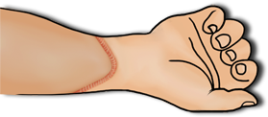
Wheat and seeds
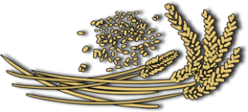
Fossil trilobite
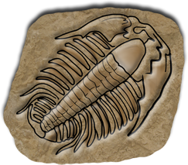

Item | Living? | Non-living? | Reasons
Virus

Mollusc shell
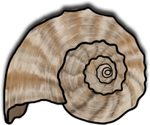
Dead frog
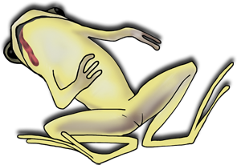
Apple
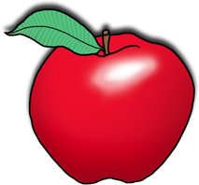
Wood
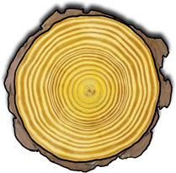
Sultanas
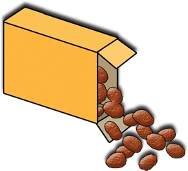

Item | Living? | Non-living? | Reasons
Boiled egg
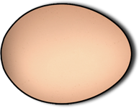
Fallen leaf


Activity 1.3 Plant life

Growing a bean seedling

Discussion:
1. What data could you collect to demonstrate the growth and development of your beans?
2. What is your hypothesis?
3. What is the independent variable and what is the dependent variable?
4. What variables have you controlled?

5. What is the control situation?
6. How can you make your experiment reliable and a fair test?
7. How could you best present the data?
Note: you may combine with your partner to record your results but the written report must be done individually. Your report should be written under the following headings:
Aim: A single sentence stating clearly what the experiment is designed to investigate.
Equipment: Make a list of the equipment that you used.
Risk assessment: Identify and assess any risks; give precautions taken.
Method: This is a record of the steps and procedures during the experiment. It is usually written in report style (third person, past tense) and should include a diagram of the experimental set-up.
Results: Record observations and measurements in a table where possible. You may also have some photographs or drawings. A graph of results should be included here.

Discussion:
Describe any trends that you observed. Refer to your graph and any other observations you recorded.
Explain your results.
Can you predict what will happen to your bean plant as it grows over the next few weeks?
Are your results similar to those of other class members? How can you be more certain of reliability?

Describe any problems in your experiment and suggest improvements.
Conclusion: Refer back to the aim of the experiment and summarise it in a sentence.

Activity 1.4 Is Sammy alive?
Watch the animation a second time, stopping after each stage to complete the table.
Event in Sammy’s life | Medical treatment given | Is Sammy alive?  (make notes of ideas)
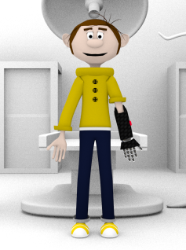
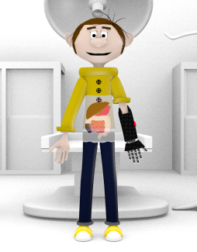
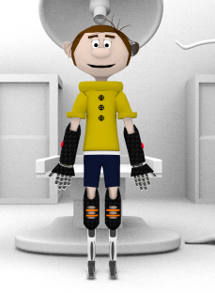
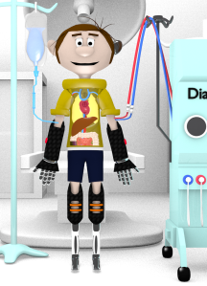

Event in Sammy’s life | Medical treatment given | Is Sammy alive?  (make notes of ideas)
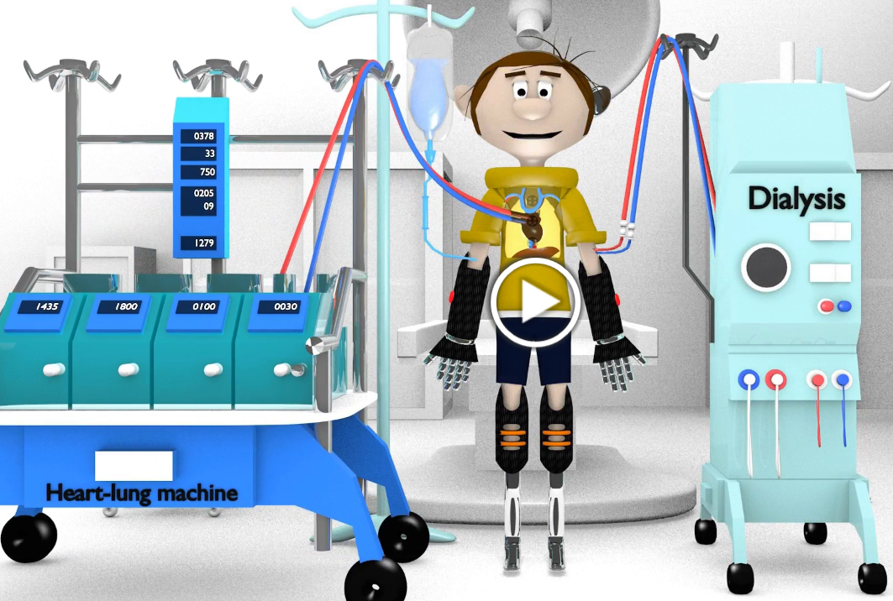

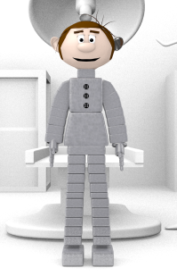

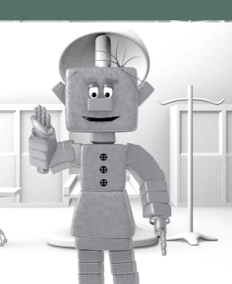

Look back at the characteristics of life.

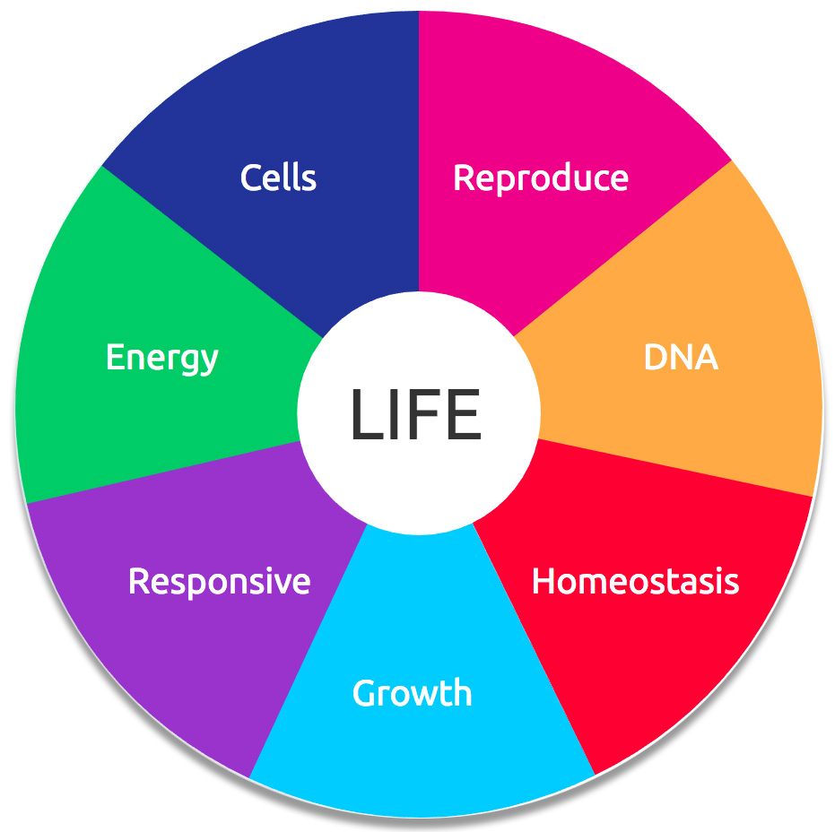

Is there a stage at which Sammy is no longer alive? Explain your reasons.

Lesson Outcomes Checklist Part 1
NAME:
ACTIVITY | LESSON OUTCOMES  At the end of these activities I can: | Please indicate if you achieved each learning outcome:  = Yes  ? = Partly  X = No
Activity 1.1 Living or non-living | - Identify everyday things as living or non-living
Activity 1.2 Characteristics of life | - recognise that the ability to move is not necessarily an indication that something is alive
 | - recall the seven characteristics of living things.
Activity 1.3 Plant life | - design and set up a fair test to investigate the growth of bean seeds
 | - understand the differences between the dependent, independent and controlled variables.
Activity 1.4 Is Sammy alive? | - discuss the characteristics needed for a person to be considered alive

Activity 2.1 The cell theory

Discussion: How did microscopes help scientists develop the cell theory?
1. Why did Robert Hooke name the little boxes he saw under the microscope "cells"?
2. Why was van Leeuwenhoek’s microscope better than the one used by Hooke?
3. Why was the Royal Society so important for the progress of science?
4. Why do you think the cell theory was an important landmark in science?

Timeline of microscope improvement
What to do:
Step 1 - Complete the following table so you can see dates and events in sequence. Some data has been filled in to start you off – add other information to complete the table.
Year | Discovery | How this helped our understanding of cells
1665 | Robert Hooke gave the name ‘cells’ to the box-like structures he observed in cork tissue. | Hooke saw that both plants and animals were comprised of cells and this has helped our understanding of living things.
1670
1830
1880
1931
1937
1965
Step 2 - Draw an even scaled timeline across the page (e.g. 1650 — 2000). Transfer the information from your table to the timeline.

Notebook - Comparing microscopes.
Click on the link and read the article on Microscopy.
1. What do you call a photograph taken using a microscope?
2. What is the difference between magnification and resolution?
3. Complete the following table comparing microscopes.
Microscope | Maximum magnification | Advantages | Disadvantages
Compound light microscope
Transmission electron microscope (TEM)
Scanning electron microscope (SEM)
4. Which microscope would you use to view the internal structure of cells at high resolution (able to distinguish fine detail)?
5. Which microscopes would you use to view living cells?

6. Which microscope would you use to view the outside surfaces of a living insect?
7. Which microscope would you use to view the 3D surfaces of microscopic objects?

Activity 2.2 How small can things be?

Finding the thickness of a sticky note
Step 1 - Look at the illustrations and brainstorm with your classmates the different meanings of the term scale.
Step 2 - How thick is a sticky note?
1. Measure the thickness of a sticky note pad. Record your answer in millimetres.
2. Count the number of sheets in the pad. (There is no need to pull it apart to do this.)

3. Divide the thickness of the pad by the number of sheets.
Thickness of sticky note = thickness of pad
number of sheets in pad
4. Record your answer in millimetres.

Discussion:
1. Is there a problem with using the millimetre unit for the thickness of one sticky note? Explain your answer.
2. When scientists measure large objects, they use metres or even kilometres. For a smaller object, such as an insect, they use millimetres. For even smaller objects, different units are used. Look at the conversion table. Convert the width of your sticky note into micrometres (μm).

3. Is this a clearer number for an object of this size?

Scale diagrams
Step 1 - Take the nail and measure its length in mm.
Step 2 - Draw a diagram of the nail at its actual size.
Step 3 - Now do scale drawings of the nail at twice its actual size and at half its size.

Step 4 - Use the watch glass to draw a circle and use it to draw a scale diagram of one side of a coin.

Step 5 - Measure the diameters of the drawing and of the actual coin. Work out the scale that your diagram has been drawn to and add the scale to your drawing.
HINT: Find how much bigger the drawing is than the actual coin by dividing:
diameter of drawing
diameter of coin

Discussion:
1. Calculate the length of a diagram of the nail at 10 times and 100 times its actual size. Which size diagram would be best if you wanted to show the nail clearly on your Notebook page?

2. What units would you use if you put a scale on the diagrams of the ant, elephant and bacterium? Does this help you to make more sense the scale diagrams?

3. The diagram of the ant is five times its actual size. Find the real life length of the ant.
4. How big are the elephant and the bacterium in real life? (Use the best units for each.)

Relative sizes
Object | Guess of relative size - biggest (1) to smallest (9) | Guess of appropriate units | Actual relative size - biggest (1) to smallest (9) | Size and appropriate units
Rice grain
Virus
Carbon atom
Sperm cell
Human egg (ovum)
Bacterium
Coffee bean
Red blood cell
Water molecule
Step 2 - Discuss with your partner and rank the items from biggest to smallest (1-9) by guessing their relative size. Put your results in the second column of the table.
Step 3 - What units do you think their sizes are measured in? Put your suggestions in the third column. Compare your ideas with other students.
Step 4 - Use the interactive to find and compare the actual sizes of the objects.
Step 5 - Complete the table by ranking the objects from biggest to smallest in column four. Record the actual size with correct units in column five.

Discussion:
What units do you think the following would be measured in:
most cells, football field, your bed, most leaves, blowflies, mobile phones, atoms?

Activity 2.3 Making little things bigger

Discussion: Focusing on high power
1. Did you need more or less light coming through the diaphragm under high power to see the image clearly?
2. Insect body parts are macroscopic but a microscope is useful to see them in more detail. Find out what the words microscopic and macroscopic mean.
3. If you have prepared slides of an insect and plant cells, check which magnification on your microscope is best to view these specimens. Discuss reasons for any differences with your classmates.

Activity 2.4 Observing cells

Cell components
Step 1 - Examine the images of cells from the human cheek, onion and Elodea (water plant), magnified X400 using a light microscope. Look for the nucleus, cell membrane, cell wall, cytoplasm, chloroplasts and vacuoles. The labelled diagram with each image will help you to check what parts are present.
Step 2 - What parts can you see in each cell? Complete the table by putting or X in each box to show what you can see.
Cell parts visible (√ or X) | Human cheek cell | Elodea leaf cell (water plant) | Onion skin cell
nucleus
cytoplasm
cell wall
cell membrane
chloroplasts

Activity 2.5 Microscope skills

Part A – Magnifying images
Step 5 - Does the ‘e’ appear the right way up under the microscope?
Step 6 - In which direction does the ‘e’ move when you move the slide:
• towards you?
• to the left?
Step 7 - Change to a higher magnification. How does this affect what you see?

Step 8 - Cut a 1 cm square from the coloured magazine page. Attach with tape to the slide.
Step 9 - Focus first on low, then on high power. What can you see?

Discussion:
1. Describe how the ‘e’ appears under the microscope.
2. What do you see as you look down the eyepiece when you move the slide in a particular direction?
3. Can you explain why these things happen?

4. What happens to the image under higher magnification? Is it as clear? Explain what you see.
5. Explain in terms of resolution what you see as you view a specimen under higher magnification.

Part B – Field of view
Step 1 - Use a minigrid slide (see photo) or make one by printing millimetre grid on an overhead transparency and cutting it into centimetre squares.
Step 2 - Focus using the lowest power objective lens. Record the magnification of the eyepiece and objective used.
Step 3 - In your field of view you will see the lines of the millimetre grid. Count the millimetres across the diameter.

Step 4 - Rotate the nosepiece to the next highest magnification, adjust the fine focus and again note the magnification and the diameter of the field of view in millimetres.
Step 5 - Record your results.
Magnification | Diameter of field of view (mm) | Diameter of field of view (µm)
Step 6 - Using the information in your table, measure the length of cells on the prepared slides.
Step 7 - How can you find the length of one cell? Record and calculate your results using this table.
Type of cell | Diameter of field of view (mm) | Number of cells in diameter of field of view | Length of cell (mm) | Length of cell (µm)

Activity 2.6 Looking at living cells

Preparing a wet mount
Step 1 - Cut a piece of onion skin (no bigger than the nail on your little finger).
Step 2 - Click here to watch a video about ‘How to make a wet mount’.
Step 3 - Make a wet mount following the instructions in the video.
Step 4 - Focus on the onion cells using a 10X objective lens, then change to 40X and adjust the fine focus and light.
Step 5 - Describe/draw in your Notebook what you saw at high power.
Step 6 - Add methylene blue stain to your slide as shown on the video.
Step 7 - How could you estimate the length of the onion skin cells? Estimate their length and compare with your classmates.

Discussion:
1. From what you know about cells, what do you think you saw in the methylene blue-stained mount that you could not see in the water one?

2. What advantages do stains provide? Are there disadvantages?
Time permitting
Does iodine stain have the same effects as methylene blue?

Activity 2.7 Drawing cells

Rules for biological diagrams
Step 1 - View the PowerPoint showing drawings of onion cells by Year 8 students.
Step 2 - Which show the details most clearly, in a scientific way?
Step 3 - Form small groups and list rules for drawing cells.

Step 4 - Discuss as a class and compile a set of drawing rules.

Drawing cells
Step 1 - Now it is your turn to draw a cell diagram. Look at the photomicrograph of onion cells and the drawing showing one whole cell. The cell that has been drawn is indicated on the photomicrograph.
Step 2 - Draw another cell from the same photomicrograph. Draw the cell about 6 cm long and in proportion. Make sure you include labels and headings.
Step 3 - Ask another class member to guess which cell you have drawn. Each cell is different, so if you have drawn a good diagram, it should be easy to pick. Does your diagram represent the cell correctly and obey the class rules?
Step 4 - Look at the photomicrographs on the next few pages of the Student Guide. Choose one and draw clear, large diagrams of one or two cells, checking the drawing rules.

Step 5 - Pick a different photomicrograph and draw clear, large diagrams of one or two cells.

Lesson Outcomes Checklist Part 2
NAME:
ACTIVITY | LESSON OUTCOMES  At the end of these activities I can: | Please indicate if you achieved each learning outcome:  = Yes  ? = Partly  X = No
Activity 2.1 Cell theory | - discuss how the development of microscopes has led to an increased understanding of cells as the basic unit of living things
 | - describe the different types of microscopes and their capabilities and limitations
Activity 2.2 How small can things be? | - appreciate the vast differences in the size of objects
 | - use appropriate units when measuring macroscopic and microscopic objects
 | - draw and interpret scale diagrams
Activity 2.3 Making little things bigger | - recall the parts of a light microscope and their functions
 | - focus a microscope under low and high power to view prepared slides
Activity 2.4 Observing cells | - identify cell components using a light microscope
Activity 2.5 Microscope skills | - describe that an image viewed with a microscope is inverted and reversed
 | - explain why resolution can be a limiting factor when viewing magnified objects
 | - use a minigrid to measure the size of objects under a microscope

ACTIVITY | LESSON OUTCOMES  At the end of these activities I can: | Please indicate if you achieved each learning outcome:  = Yes  ? = Partly  X = No
Activity 2.6 Looking at living cells | - prepare a wet mount of cells
 | - add a stain to a wet mount to show up various cell components
Activity 2.7 Drawing cells | - make a labelled biological drawing that is accurate, to scale and in proportion

Activity 3.1 What’s inside a cell?

Cell types
Step 1 - Look at diagrams of the four main types of cells on page 33 of the Student Guide.
Step 2 - Record their similarities and differences.
Step 3 - Discuss your findings with the class.

Notebook: Classifying cells
Hover on each of the micrographs to see the cells in detail. Note the structures which make up the cell and its shape.
Complete the table below, noting which structures are in each cell. Classify the cell as animal, plant, fungal or bacterial. Estimate the length of each cell.
Cell | Nucleus | Cell wall | Chloroplasts | Other information | Cell type? | Length of cell (µm)
A
B
C
D

Activity 3.2 What makes cells function?

Jigsaw activity
Step 1 - Your task is to research and understand your cell part. You will need to explain it to your group, so Notebook as you go.
Step 2 - After the researching the group comes together and each member takes turns to explain their information. Other members learn about the other three cell parts and take their own notes. A table is a useful way to summarise your findings.
Cell part | Structure (a diagram could help) | Main roles | Other information
Mitochondrion
Chloroplast
Nucleus
Cell membrane

Step 3 - Together, the group will discuss any connections between the various cell parts. Each member will record any new scientific understanding they gained about how cell parts work together.

Step 4 - The groups join a class discussion where a representative from each will present their new understandings.

Notebook: Relating cell structure to function.
1. Euglena have many chloroplasts. What does this tell us about how they are able to obtain food?
2. Amoeba have no chloroplasts. What does this tell us about how they are able to obtain food?
3. Paramecium has many cilia around the outside of its body. How does it move around?

4. Paramecium also have many cilia around their primitive mouth. How do the cilia here help Paramecium?
5. Take a closer look at how the Amoeba moves. Do you think it would be an advantage for this organism to have a cell wall around it? Explain your answer.

Activity 3.3 Yeast metabolism

Part A: What a gas!
Step 1 - Form a group of three or four students.
Step 2 - Plan your experiment:
• what equipment will you need?
• how will you set it up?
Step 3 - Set up the experiment.
Step 4 - Observe the results over 30 minutes. While you wait, draw a table in your Notebook to show your results clearly.

Part B: Budding cells.
Step 1 - Set up your microscope and ensure the lenses are clean.
Step 2 - Take one small drop of yeast solution from one of your flasks and place it in the centre of your slide. Which is the best one to choose?

Step 3 - Carefully lower the cover slip from one side using the mounted needle or toothpick.
Step 4 - Wipe away excess water on your slide.
Step 5 - Use the 10X objective lens and coarse focus to look at the yeast cells. They are very small so, once you have them in focus, change to the 40X lens and check the fine focus and light.
Step 6 - In your Notebook draw a few cells. Can you see any cells that are joined together? If so draw them.

Discussion:
1. What evidence is there that a gas is being produced?
2. What gas do you think it is? Explain.

3. Did the experiment indicate that yeast prefers to live at any particular temperature? Explain.
4. Draw a line graph to show the effect of temperature on the amount of gas produced.
5. Write a conclusion for this part of the experiment.

Activity 3.4 Cell division
What are the two main reasons for binary fission?
Volvox may have been one of the first multicellular organisms. Can you explain why?

Notebook: Why do cells divide?
1. Draw a cartoon strip to show the stages in mitosis in an animal cell.
2. Why is binary fission an effective way for unicellular organisms to reproduce?

3. When unicellular organisms reach their maximum size, they stop growing and divide. Can you think of a reason for this?
4. Now view the video clips showing cell division in paramecium, euglena and yeast. Think about what you have learnt about cell classification:
a. What do these three organisms have in common?
b. How are they different?

Activity 3.5 Why are cells so small?

Diffusion into agar blocks
Step 1 - Read the procedure and think about how you will record your results in your Notebook.
Step 2 - Half fill the beaker with sulfuric acid.
Step 3 - Carefully lower each agar block into the acid, making sure they do not touch.
Step 4 - Start the stopwatch when you put the blocks in the acid. The acid in the beaker will diffuse into the agar, turning the pink indicator clear.
Step 5 - Observe each agar block for 15 minutes. If any turn completely clear, note the time.
Step 6 - Pour the acid out of the beaker and rinse the blocks well with water.
Step 7 - Cut each block down the centre into two and measure the length of any remaining pink area.

Discussion:
1. What happens to the extent of diffusion as the blocks get bigger? Try to explain this. It’s tricky!
2. How does this affect the metabolism of a cell?

3. Not all cells are cubes or spheres. Look at the cells in the lower right of page 40. Order them from most to least efficient for diffusion of materials in and out of the cell.
4. Why can some cells, such as eggs, be much larger than other cells?
5. The relationship between surface area and volume can be used to explain many everyday things. Try these!
a. Why is a teabag quite flat rather than spherical?
b. Why are you more likely to get frost-bite on your fingers, toes and ears than on your cheeks?

c. Why do snakes coil up in cold weather?
d. Why are teapots ‘short and stout’?
e. How could you cool down a very hot roast potato quickly?
f. What is a three-dog night?

Lesson Outcomes Checklist Part 3
NAME:
ACTIVITY | LESSON OUTCOMES  At the end of these activities I can: | Please indicate if you achieved each learning outcome:  = Yes  ? = Partly  X = No
Activity 3.1 Cell theory | - classify cells according to their shape and structure as plant, animal, bacterial or fungal.
Activity 3.2 What makes cells function? | - discuss the roles of organelles in cell metabolism
 | - develop literacy by exploring and reading digital texts to comprehend and communicate scientific information
Activity 3.3 Yeast metabolism | - describe some of the characteristics of life shown by yeast cells
 | - plan and carry out a controlled experiment
 | - draw and interpret a line graph from experimental data
Activity 3.4 Cell division | - describe mitosis as a type of cell division producing two genetically identical cells
 | - list situations where binary fission and mitosis occur
Activity 3.5 Why are cells so small? | - describe the relationship between size of cells and their surface-area: volume ratio
 | - explain that cells are limited in size because diffusion becomes less efficient as size increases

ACTIVITY | LESSON OUTCOMES  At the end of these activities I can: | Please indicate if you achieved each learning outcome:  = Yes  ? = Partly  X = No
Activity 3.6 Life on the Barrier Reef | - correct use of a microscope
 | - biological drawing
 | - drawing objects to scale.

Activity 4.1 Life in water

What life is there in pond water?
1. Which organisms were unicellular (one-celled)?
2. Which were multicellular (many-celled)?
3. Which were plants and which were animals?
4. What characteristics of life do they display?

5. What characteristic of life does movement indicate?

Activity 4.2 Cells Specialise
Step 6 - Draw a labelled diagram of a few cells of your plant tissue.
Step 7 - Repeat Steps 1-6 for another plant tissue.
Step 8 - Choose a prepared slide and repeat Steps 5 and 6. Draw a labelled diagram of a few cells.

Tissues quiz
1. In biology, what is a tissue?

2. What process must happen for tissues to form from a single cell?
3. How are all tissues different? Explain why.
4. How are palisade cells in plant leaves specialised for their job?
5. Why are the spongy cells in the centre of the leaf (mesophyll) spaced apart?

6. How does lung tissue differ from others you have seen?
7. Why are bone cells separated by other material?’ What could this material be?
8. Explain why multicellular organisms can only function with many kinds of specialised cells and tissues.

Activity 4.3 Putting it all together
1. List the similarities and differences between the structure of flowering plants and humans. A table is useful.
2. Define in your own words the term body system.
3. What organs make up the human digestive system?
4. Why do you think the stomach is made of muscle tissue?

5. Explain how the leaf of a plant suits the the roles of gas exchange (carbon dioxide moving in and oxygen moving out) and photosynthesis (making food).

Activity 4.4 Organs and Systems

Digestive system
1. Explain why humans need food.
2. Why do we need to digest food?
3. What is the first process in digestion?
4. How does digested food reach all the cells in our body?

5. What is removed from the food in the small intestine?
6. What is removed from the food in the large intestine?
7. What do we call the remaining waste material that leaves the large intestine?

Activity 4.5 New skin

Professor Fiona Woods
1. What do plastic surgeons do?
2. What are some of the functions of skin?
3. Why are burns treated by plastic surgeons?
4. What do you think Prof. Wood means by not wanting to believe that all today’s treatments are good enough?

5. What sort of childhood did Fiona Wood have? Has it influenced her career?
6. What qualities have contributed to Prof Wood’s success as a surgeon, research scientist and mother?

Activity 4.7 Xylem tissue
Step 1 - Remove the stem from the water and wipe off excess liquid. Observe the stem to see how far the red dye has moved. Has the dye reached the leaves?
Step 2 - Cut a very thin slice across the stem. Place onto a slide with a drop of water and cover slip and observe under your microscope. Can you see the cells that are dyed red? Draw some of the xylem cells.
Step 3 - Cut the stem lengthways. What do the red-stained cells look like?

Looking at stomata
Step 1 - Paint a strip of polish on the upper and lower surfaces of a leaf.
Step 2 - When dry, peel off the strips and place on two separate slides labelled U and L (upper and lower).

Step 3 - Observe the slides under the microscope. Do you find the same number of stomata on both surfaces of the leaf?
Step 4 - Label a diagram of one stoma at high power.

Discussion:
1. Which surface of the leaf has most stomata? How does this help the plant?
2. Stomata have surrounding guard cells which can swell up to open them. What would happen if the stomata were closed?

3. Stomata often close in the heat of the day and are open in the early morning and late afternoon. Why?
4. What gas do plants take in through their stomata to use in photosynthesis?

Lesson Outcomes Checklist Part 4
NAME:
ACTIVITY | LESSON OUTCOMES  At the end of these activities I can: | Please indicate if you achieved each learning outcome:  = Yes  ? = Partly  X = No
Activity 4.1 Cell theory | - use a microscope to observe microorganisms
 | - classify organisms based on the structure of their cells.
Activity 4.2 Cells specialise | - describe a tissue as a group of similar cells carrying out a specific function
 | - recognise that the cells in tissues are specialised in structure to carry out their particular functions.
Activity 4.3 Putting it all together | - describe the relationships between cells, tissues, organs and body systems
 | - discuss why multicellular organisms require cell specialisation to survive
Activity 4.4 Organs and systems | - discuss the role of body organs and systems in maintaining effectively functioning organisms
 | - recall the main parts and functions of the circulatory, digestive and kidney systems

ACTIVITY | LESSON OUTCOMES  At the end of these activities I can: | Please indicate if you achieved each learning outcome:  = Yes  ? = Partly  X = No
Activity 4.5 New skin | - discuss the importance of science in advancements in medicine
 | - develop literacy skills by reading, viewing and listening to media forms to analyse and communicate information
 | - develop an understanding that perseverance is necessary to make significant achievements
Activity 4.6 Let’s look inside! | - describe the main structures of a squid and their functions.
Activity 4.7 Plant plumbing | - Describe how water and nutrients are transported to all parts of a plant
 | - Discuss the role of stomata in plant metabolism
Activity 4.8 How does a multicellular organism function? | - Describe the relationship between cells, tissues, organs and systems

Activity 5.1 Life and death of intestinal cells
You may want to view the animation several times, pausing to consider what you have seen and make notes. Write a story describing what is happening in the animation. Show you understand the following terms by using them correctly:
• stem cell
• transition cell
• secretory cell
• absorption cell
• goblet cell
• programmed cell death
• necrosis
• mucous
• bacteria
• toxin
• tumour

Activity 5.2 Professor Barry Marshall
1. What is a gastroenterologist?
2. Explain in three sentences the life-saving discovery for which Professor Barry Marshall was awarded the Nobel Prize for Medicine in 2005.
3. Why were drug companies reluctant to accept his findings?
4. What recent work has he been involved in?

5. His experiments are a good study into how to apply the scientific method to prove an hypothesis. What was Prof. Marshall’s hypothesis?
6. Why did he have an endoscopy before drinking the solution containing Helicobacter pylori?
7. List as many things as you can about his experiments that make them scientifically valid.
8. Was a single experiment enough to prove that H. pylori was the cause of gastritis and ulcers? Explain.

Form groups of two or three other students.
9. In Activity 4.5 you learnt about the work of another Australian medical scientist, Prof. Wood. On butcher paper, list the similarities and differences between them. You might include their early lives, education, other life events and their personalities and beliefs.

Activity 5.3 Teeth and diet
In a four-column table in your Notebook, list:
- the three organisms on this page with teeth
- their energy (food) source
- their classification by food source
- a description of their teeth.

Discussion:
1. What kind of teeth do you think the following animals have and why?
a. Koala
b. Tasmanian devil

c. Shark
d. Wombat
e. Crocodile
2. Mosquitoes and houseflies feed without teeth. Can you think of other unusual ways of taking in and digesting food?

Activity 5.4 How do they survive?

Discussion:
1. Look at the invertebrates on page 67 and the vertebrates on page 66. Can you see any trends in:
- type of reproduction
- where the eggs are laid and fertilised
- number of eggs laid/young produced
- likelihood that any individual will survive to become an adult
- care of eggs/young
Draw a table to help see patterns clearly.
2. Discuss why some animals lay so many eggs.
3. Why don’t the numbers of adults of that species increase dramatically?

Life cycles
Watch the five videos in this activity before answering the questions. You may refer to them again as you go.
1. Think back to the table you drew at the start of this lesson. Did the videos clarify your ideas? Update the table if necessary.
2. Why do land animals tend to use internal rather than external fertilisation?
3. How are eggs laid on land different to those laid in water? Explain.
4. What advantages do young gain from developing inside a mother’s body?

5. Choose one Australian animal and explain how its reproductive strategies help the young to survive.
Click on the life cycle of a butterfly and follow the steps carefully.
6. Draw a lifecycle for a:
- Frog
- Echidna
7. How are these life cycles:
a. Similar?

b. Different?

Activity 5.5 Plants reproduce too!

Pollination and fertilisation
1. Why do plants expend so much energy to attract insects and other animals to their flowers?
2. Explain the difference between pollination and fertilisation?
3. Describe two examples of how flowers attract pollinators.

Investigating flower structure
Step 1 - Choose one flower and observe as a whole. If it is a compound flower, you will need to separate one flower to study.
Step 2 - Make a longitudinal cut through the centre of the flower.
Step 3 - Identify all the structures. You may need a hand lens if the flower is small.

Step 4 - Draw a labelled cross-sectional diagram of the flower.
Step 5 - Repeat steps 1-4 for at least two other flower specimens.
Step 6 - Scrape a small amount of pollen from the stamens of a flower onto a microscope slide.
Step 7 - Add a drop of water and a cover slip.
Step 8 - Observe the pollen grains with the microscope, using X10 and X40 objective lenses. Draw a diagram to show their shape.
Step 9 - Repeat this for other grains.

Discussion:
1. What is a compound flower? What advantages and disadvantages does this bring?
2. Do you think your flowers are pollinated by wind or animals? Why?
3. Could you use pollen grain structure to identify a species? Explain.

Activity 5.6 But there’s another way!

Part A – Asexual reproduction
Examine the specimens around the room to identify the type of asexual reproduction that they demonstrate. Then complete the table below and answer the discussion questions.
Type of asexual reproduction | Name of organism | Description of asexual reproductive process
bulb
rhizome
runner
tuber

Discussion:
1. Do any of these examples involve any other individuals to produce offspring? Explain.
2. Can any of these organisms carry out sexual reproduction?

4. Give three advantages of asexual reproduction.

Part B – Comparing sexual and asexual reproduction
What to do:
Step 1 - Form groups of three to four.
Step 2 - Look at the examples on page 73 and in Activities 5.4 and 5.5. Discuss with your classmates the differences between sexual and asexual reproduction.
Step 3 - Work together to complete the following table. Describe how each method of reproduction differs in these features.
Features | Sexual reproduction | Asexual reproduction
Similarity to parents?
Time taken to make offspring?
Involvement of another individual?
Survivability?
Amount of energy used?
Adaptation to the environment?

Activity 5.7 Presenting and interpreting experimental results

Part A –Presenting results in a table
Step 1 - Look at the table and hints on this page and check the other tables in this unit.
Step 2 - Read the account (page 74) of an experiment carried out by Anna, a Year 8 student.
Step 3 - Construct a table so that Anna can collect her data. What would be a good title? How many columns will you need? What units will the measurements be in?

Constructing graphs
Step 1 - Read the instructions for drawing a line graph on page 75 and look at the example.
Step 2 - Construct a line graph from the table of lizard body temperatures by following the guidelines.
Step 3 - Construct a graph from the data in the table on page 75 about the effect of fertiliser on plant growth.

Practice in interpreting graphs
1. Graph of temperature against time for cooling water.
a. Describe the trend in the graph.
b. Try to explain why the water cools over time.
2. Line graph of lizard body temperature.
a. Describe the trend in the graph.
b. Try to explain the shape of the graph.
3. Line graph of effect of fertiliser on plant growth.
a. Describe the trend in the graph.
b. Try to explain the shape of the graph.

Activity 5.8 So how did it grow?

Growth of bean plant
Today you will collate all the information you have been collecting about the growth of your bean plants. You will be tested on your ability to:
- present results in a table
- construct and interpret graphs
- draw valid conclusions from your observations.
Your teacher will tell you more.

Lesson Outcomes Checklist Part 5
NAME:
ACTIVITY | LESSON OUTCOMES  At the end of these activities I can: | Please indicate if you achieved each learning outcome:  = Yes  ? = Partly  X = No
Activity 5.1 Is death a part of life? | - develop literacy by interpreting visual media.
 | - describe the death and renewal of cells as part of the maintenance of healthy organisms.
Activity 5.2 A scientific breakthrough! | - discuss the importance of scientific methodology in advancements in medicine.
 | - develop literacy skills by reading, viewing and listening to media forms to analyse and communicate information.
 | - develop an understanding that perseverance is necessary to make significant achievements
Activity 5.3 Why the difference? | - describe the relationship between mouthparts and diet.
 | - explain how the skeletons of animals make them well adapted to their lifestyles.
 | - describe the main differences in environment between organisms that use lungs and gills as respiratory systems.
Activity 5.4 Reproductive strategies in animals | - recognise that animal reproductive strategies are related to their environment and the complexity of the organism.
 | - recall the main parts and functions of the circulatory, digestive and kidney systems.

ACTIVITY | LESSON OUTCOMES  At the end of these activities I can: | Please indicate if you achieved each learning outcome:  = Yes  ? = Partly  X = No
Activity 5.5 Plants reproduce too! | - describe the role of a flower in the sexual reproduction of plants.
Activity 5.6 But there’s another way! | - describe asexual reproduction as cloning to produce individuals genetically identical to the parent plant.
 | - describe some methods of asexual reproduction in plants.
 | - discuss the differences and advantages/disadvantages of sexual and asexual reproduction.
Activity 5.7 Presenting and interpreting experimental results | - present data in a table.
 | - construct and interpret line graphs.
 | - draw valid inferences and conclusions from experimental.

Acknowledgements
Science by Doing is supported by the Australian Government Department of Education, Skills and Employment. The views expressed here are those of the author and do not necessarily represent the views of the Australian Government Department of Education, Skills and Employment.
Copyright
© Australian Academy of Science, 2021
From Little Things Big Things Grow, Student e-Notebook: ISBN 978-0-85847-791-9
Published by the Australian Academy of Science
GPO Box 783
Canberra ACT 2601
Telephone: 02 6201 9400
www.science.org.au

The details of the relevant licence conditions are available on the Creative Commons website (accessible using the links provided) as is the full legal code for the Creative Commons Attribution-NonCommercial-ShareAlike 4.0 International (CC BY-NC-SA 4.0) licence (https://creativecommons.org/licenses/by-nc-sa/4.0/legalcode).
Click here for a full version of unit acknowledgements and sources or logon to www.sciencebydoing.edu.au.
Last revised: 29 October 2021

